MIDDLE ATLANTIC REGION
FEDERATION OF JEWISH MEN’S CLUBS

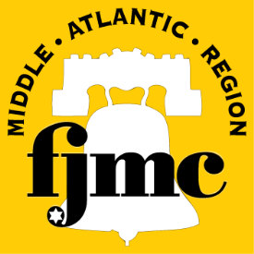

17TH ANNUAL MAN OF THE YEAR DINNER

Sunday, December 7, 2014
Congregation Beth El
8000 Main Street
Voorhees, NJ

Reservation Deadline, including payment in full
November 19, 2014

Full Cocktail Reception with Hot and Cold Hors d’Oeuvres
and a three course dinner catered by Prestige Caterers

Choice of entree (must be specified in your order):

Chicken Roulade
(Spinach, sundried tomatoes & mushrooms, bourbon glaze)
Miso Glazed Salmon
(Glazed salmon in tropical fruit salsa)
Vegetable Wellington
(Vegetarian)

Couvert: $70.00/person

Name of Guest(s): _______________________________________________

Phone and/or email contact information: __________________________________

Entree Choice(s): ( ) Chicken ( ) Fish ( ) Vegetarian (please fill in number)
Amount Enclosed $___________

Send all reservations and checks payable to “Your Club” to:
Your Club’s Man of the Year Chairman

